Hill Start Assist Control Function – CGEA 1.3

Functional Description

The Hill Start Assist (HSA) feature assists the driver in hill-starting the vehicle uphill. The driver is able to drive off on a slope easily (without rolling downhill) and comfortably (without lurching uphill) without the need to apply the park-brake.

The Hill Start Assist Feature is present on both automatic transmissions and manual transmissions. However, the settings menu to allow you to turn HSA on/off is restricted to manual transmissions. Note that HSA is optional on manual transmissions. For automatic transmissions, HSA is always on. There is also a warning message for HSA failure “Hill Start Assist Not Available”.

Starting in MY2019 with U625/U611 the Settings are migrating from the cluster to Center stack. This STSS supports displaying settings in the cluster or configuring the cluster settings off if they are displayed in the Center stack. When configured for settings in the Center Stack, for this feature, the cluster acts as a signal gateway between the Center Stack and the ABS module. Any feature setting that the cluster acts as gateway for by definition only has one setting (i.e. the setting is not part of Enhanced Memory). Thus, the requested Index from the Center Stack is always just copied back in the IPC response.

Hill Start Assist Control Function is displayed only in the Message Center while it is in the appropriate SETUP display. See Message Center X Display_Y Button Interface Section, where X and Y are appropriate values in this document for details on when this display is active.

Interfaces

Interface Context Diagram (I/O Block Diagram)

Figure 1 HSA Function Context Diagram
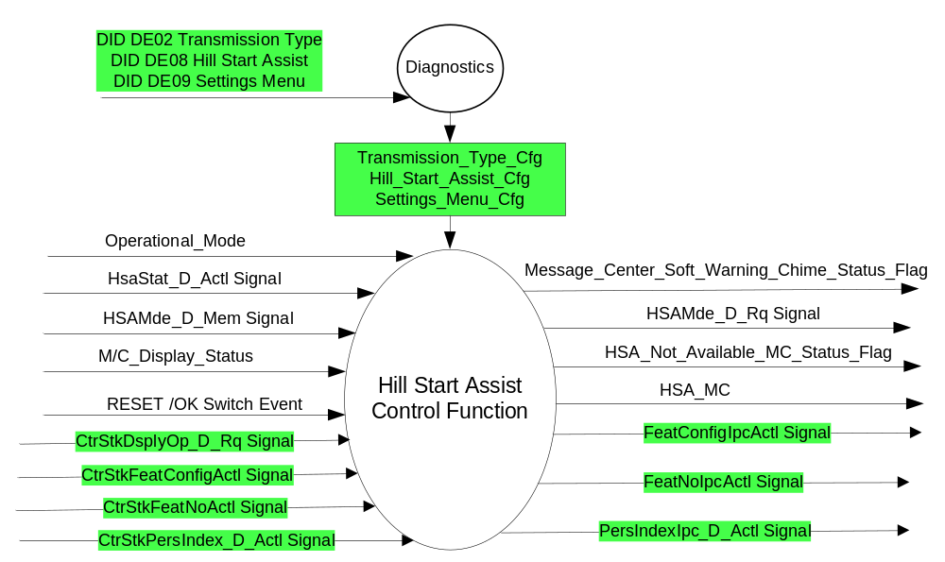

Inputs

- INTERNAL:
- Operational_Mode
- RESET / OK Switch Event
- Transmission_Type_Cfg (defined in Fuel Level Gauge STSS)
- Settings_Menu_Cfg
- Hill_Start_Assist_Cfg
- M/C_Display_Status
- MUX message on the CAN Bus from ABS

- HsaMde_D_Mem Signal
Signal Name | Size (bits) | Detail | Units | Res. | Offset | State Encoded | Min | Max
HsaMde_D_Mem | 2 |  | SED | 1 | 0 |  | 0x0 | 3 (0x3)
 |  | Off |  |  |  | 0x0
 |  | Automatic |  |  |  | 0x1
 |  | Manual |  |  |  | 0x2
 |  | Undefined |  |  |  | 0x3
- HsaStat_D_Actl Signal
Signal Name | Size (bits) | Detail | Units | Res. | Offset | State Encoded | Min | Max
HsaStat_D_Actl | 3 |  | SED | 1 | 0 |  | 0x0 | 7 (0x7)
 |  | Inactive |  |  |  | 0x0
 |  | FindingGradient |  |  |  | 0x1
 |  | ActiveBrakePedalPressed |  |  |  | 0x2
 |  | ActiveBrakePedalReleased |  |  |  | 0x3
 |  | FastRelease |  |  |  | 0x4
 |  | SlowRelease |  |  |  | 0x5
 |  | Failed |  |  |  | 0x6
 |  | Undefined |  |  |  | 0x7

- MUX message on the CAN Bus from APIM:

- CtrStkFeatConfigActl Signal
Signal Name | Size  (bits) | Detail | Units | Res. | Offset | State  Encoded | Min | Max
CtrStkFeatConfigActl | 16 | - | Undefined | 1 | 0 |  | 0  (0x0) | 65535 (0xFFFF)

- CtrStkFeatNoActl Signal
Signal Name | Size  (bits) | Detail | Units | Res. | Offset | State  Encoded | Min | Max
CtrStkFeatNoActl | 16 | - | Undefined | 1 | 0 |  | 0  (0x0) | 65535 (0xFFFF)

- CtrStkPersIndex_D_Actl Signal
Signal Name | Size  (bits) | Detail | Units | Res. | Offset | State  Encoded | Min | Max
CtrStkPersIndex_D_Actl | 3 |  | SED | 1 | 0 |  | 0 (0x0) | 7 (0x7)
 |  | PERS_1 |  |  |  | 0x0
 |  | PERS_2 |  |  |  | 0x1
 |  | PERS_3 |  |  |  | 0x2
 |  | PERS_4 |  |  |  | 0x3
 |  | Vehicle |  |  |  | 0x4
 |  | Unused_1 |  |  |  | 0x5
 |  | Unused_2 |  |  |  | 0x6
 |  | Unused_3 |  |  |  | 0x7

- CtrStkDsplyOp_D_Rq Signal
Signal Name | Size  (bits) | Detail | Units | Res. | Offset | State  Encoded | Min | Max
CtrStkDsplyOp_D_Rq | 3 |  | SED | 1 | 0 |  | 0 (0x0) | 7 (0x7)
 |  | Null |  |  |  | 0x0
 |  | Query |  |  |  | 0x1
 |  | Set |  |  |  | 0x2
 |  | Upload |  |  |  | 0x3
 |  | Restore |  |  |  | 0x4
 |  | Copy |  |  |  | 0x5
 |  | Unused_1 |  |  |  | 0x6
 |  | Unused_2 |  |  |  | 0x7

Outputs
- HSA_MC (Setup display)
- HSA_Not_Available_MC_Status_Flag, which is used to control the state of the Hill Start Assist Not Available message.
- Message_Center_Soft_Warning_Chime_Status_Flag
- MUX message on the CAN Bus

- HsaMde_D_Rq Signal
Signal Name | Size (bits) | Detail | Units | Res. | Offset | State Encoded | Min | Max
HsaMde_D_Rq | 2 |  | SED | 1 | 0 |  | 0x0 | 3 (0x3)
 |  | Off |  |  |  | 0x0
 |  | Automatic |  |  |  | 0x1
 |  | Manual |  |  |  | 0x2
 |  | Undefined |  |  |  | 0x3

- FeatConfigIpcActl Signal
Signal Name | Size  (bits) | Detail | Units | Res. | Offset | State  Encoded | Min | Max
FeatConfigIpcActl | 16 | - | Undefined | 1 | 0 |  | 0  (0x0) | 65535 (0xFFFF)

- FeatNoIpcActl Signal
Signal Name | Size  (bits) | Detail | Units | Res. | Offset | State  Encoded | Min | Max
FeatNoIpcActl | 16 | - | Number | 1 | 0 |  | 0  (0x0) | 65535 (0xFFFF)

- PersIndexIpc_D_Actl Signal
Signal Name | Size  (bits) | Detail | Units | Res. | Offset | State  Encoded | Min | Max
PersIndexIpc_D_Actl | 3 |  | SED | 1 | 0 |  | 0 (0x0) | 7 (0x7)
 |  | PERS_1 |  |  |  | 0x0
 |  | PERS_2 |  |  |  | 0x1
 |  | PERS_3 |  |  |  | 0x2
 |  | PERS_4 |  |  |  | 0x3
 |  | Vehicle |  |  |  | 0x4
 |  | Unused_1 |  |  |  | 0x5
 |  | Unused_2 |  |  |  | 0x6
 |  | Unused_3 |  |  |  | 0x7

Function/Performance

Operational Modes

Mode | Differentiating Vehicle Conditions
Sleep Mode | HSA_MC, HSA_Not_Available_MC_Status_Flag Disabled
Limited Mode | HSA_MC, HSA_Not_Available_MC_Status_Flag Disabled
Normal Mode | HSA_MC, HSA_Not_Available_MC_Status_Flag Enabled / Disabled
Crank Mode | HSA_MC, HSA_Not_Available_MC_Status_Flag Enabled / Disabled

Voltage Levels

Refer to the Cluster Features table located in the Operational Modes and Voltage Range Strategies Section in this SPSS.

Human-Machine Interface

Visual

Indicator Graphics / Display Format
For High End Display (SHMI), refer to “<Program> Cluster Menu Structure and Menu Nav.xls”

LEVEL 0 | LEVEL 1 | LEVEL 2 | LEVEL 3
Settings >  (t#018, t#237) | Driver Assist >  (t#450, t#450b) | # Hill Start Assist (t#470)
 |  | Hill Start Assist > | * On
 |  |  | * Off

Indicator Color Coordinates

Reference section COLOR & ILLUMINATION REQUIREMENTS (GRAPHICS)

Indicator Characteristics

Refer to Message Center X Display_Y Button Interface Section, where X and Y are appropriate values in this document.

Audio

The Message Center Soft Warning Chime is associated with this Warning.
Message_Center_Soft_Warning_Chime_Status_Flag

Switch Control Logic

Consumer access to the Autolamp Control Configuration shall be as specified in the message center basic functionality display as specified in Message Center X Display_Y Button Interface Section, where X and Y are appropriate values in this document.

System Accuracy

Within a 100msec of receiving a message that results in a change of state the cluster will update the display to the proper status.

Operation: Performance and Functional

Subsystem Algorithm Flowchart / State Diagram

Figure 2: HSA Diagnostic Configuration Flowchart

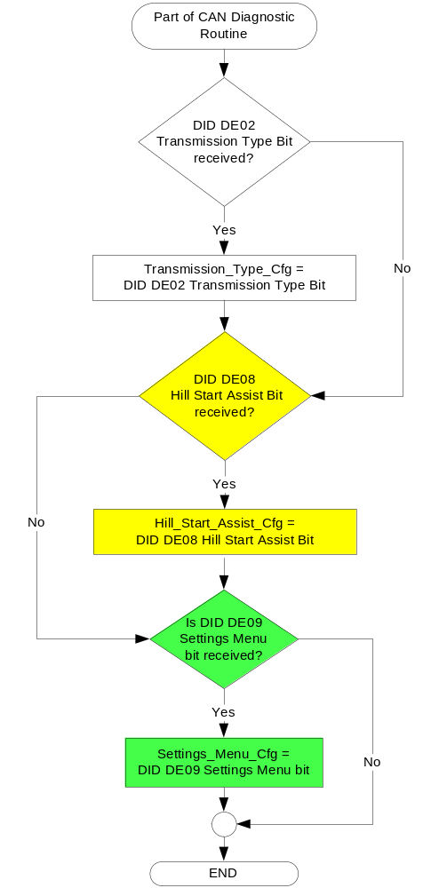

Figure 3: HSA input request Flowchart

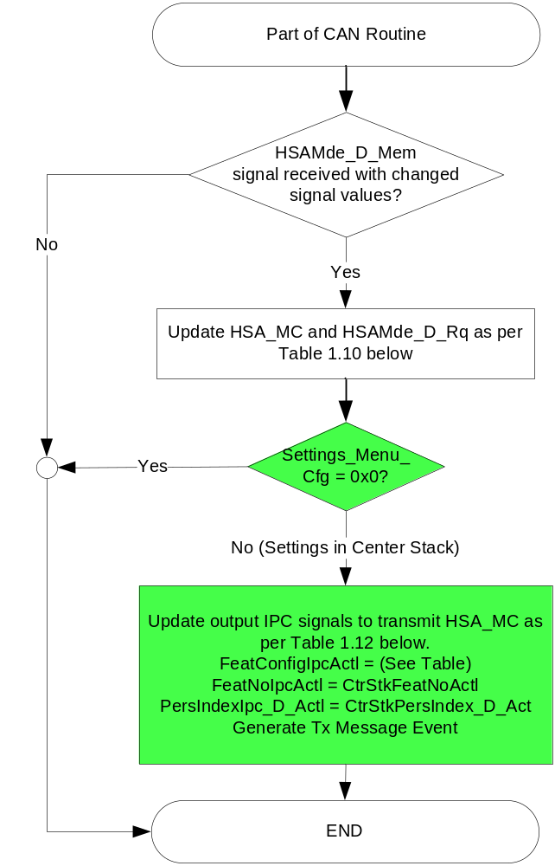

- HSA_MC and HSAMde_D_Rq Signal based on HSAMde_D_Mem

HSAMde_D_Mem | HSA_MC | HSAMde_D_Rq
Off (0x0) | Off (0x0) | Off (0x0)
Automatic (0x1) | On (0x1) | Automatic (0x1)
Manual (0x2) | Error (0x3) | Manual (0x2)
Undefined (0x3) | Error (0x3) | Undefined (0x3)
Missing per section 1.4.1 | Error (0x3) | Undefined (0x3)

Figure 4. Hill Start Assist Centerstack Signal Gateway Routine Flowchart
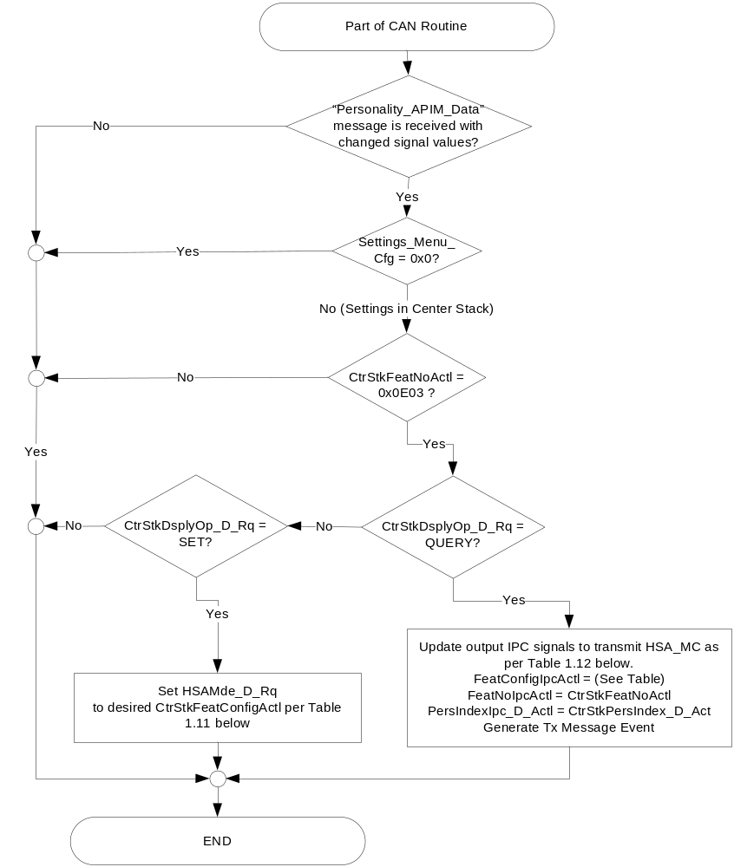

- HSAMde_D_Rq State based upon CtrStkFeatConfigActl
CtrStkFeatConfigActl  Signal | Display Menu  In Center Stack (For reference) | HSAMde_D_Rq Signal
On (0x1) | ☑ Hill Start Assist | 0x1
Off (0x0) | ◻ Hill Start Assist | 0x0
Unused (0x2-0xFF) | ◻ Hill Start Assist | 0x0

- FeatConfigIpcActl State based upon HSA_MC
HSA_MC | Display Menu  In Center Stack (For reference) | FeatConfigIpcActl  Signal
On (0x1) | ☑ Hill Start Assist | 0x1 (On)
Off (0x0) | ◻ Hill Start Assist | 0x0 (Off)
Unused (0x2)  Unused (0x3)  Unused (0x4) | ◻ Hill Start Assist | 0x0 (Off)

Figure 5: HSA output CMD Flowcharts

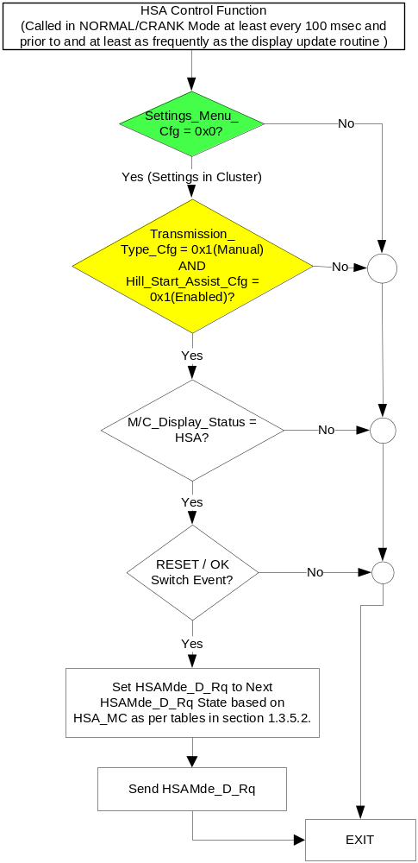

NOTE: In the HSA Function Flowchart, the definition of "RESET / OK Switch Event" is defined in Message Center X Display_Y Button Interface Section, where X and Y are appropriate values in this document.

- State Matrix for Hill Start Assist Not Available Warning
Operational_Mode | HsaStat_D_Actl Signal | HSA_Not_Available_  MC_Status_Flag
Normal or Crank | Failed (0x6) | Active
Normal or Crank | Missing | Inactive
All Other Cases |  | Inactive
- Hill Start Assist Not Available MC Status Flag to MC Warning Message ID

HSA_Not_Available_MC_Status_Flag | MC Warning Message ID | Active Chime_Status_Flag
Active | W1429 (Hill Start Assist Not Available) | Message_Center_Soft_Warning_  Chime_Status_Flag

Operation Description (supports algorithm flowchart /state diagram)

- SHMI Display and Next HSAMde_D_Rq State based upon HSA_MC
HSA_MC | Display Menu | 5-Button Switch Selection Event | Next HSAMde_D_Rq State
Off (0x0) | 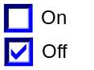 | Up/Down + OK  (Select On) | Automatic (0x1)
On (0x1) | 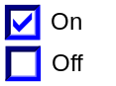 | Up/Down + OK  (Select Off) | Off (0x0)
Error (0x3) | 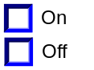 | Up/Down + OK  (Select On, Off)) | (0x0) (If Off is selected)  (0x1) (If On is selected)
Note: This menu is only displayed when Hill_Start_Assist_Cfg = 0x1(Enabled) AND Transmission_Type_Cfg = 0x1(Manual) and Settings_Menu_Cfg = 0x0 (Cluster).

- Personalization Feature Number Definition:
Feature Name | Feature Num | Cfg Num | Cfg Value
Hill Start Assist | 0x0E03 | 0x00 | Off / Disabled
Hill Start Assist | 0x0E03 | 0x01 | On / Enabled

Function Safety Classification (EMC)

Class B

Memory Storage

- Function Parameters
Parameter Name | Description | Value at  Battery Connect | Value at  Module Wake-up
HSA_MC | Output displayed in the M/C | 3 (0x3) | Do Not Init
Hill_Start_Assist_Cfg | Defined in DID DExx. 0 = Disabled, 1 = Enabled | Use Stored Value | Use Stored Value
HsaMde_D_Rq Signal | Output CAN signal sent from the IPC. Requested operating mode of the Hill Start Assist (HSA) function. | 3 (0x3) | Do Not Init
HsaMde_D_Mem Signal | Input CAN signal sent from the ABS. Operating mode selection for the Hill Start Assist (HSA) function that is saved in ABS memory. | 3 (0x3) | Do Not init
HsaStat_D_Actl Signal | Input CAN signal sent from the ABS. | Inactive (0x0) | Inactive (0x0)
HSA_Not_Available_MC_Status_Flag | State variable used by M/C Warning Arbitrator | INACTIVE | INACTIVE
Transmission_Type_Cfg | Defined in DID DE00 in Fuel Gauge STSS. 0 = Auto, 1= Manual | Use Stored Value | Use Stored Value
M/C_Display_Status | State Indicator to identify which text is currently being displayed on Message Center display. See * | See * | See*
RESET/ OK Switch Event | Event that is indicated as per the switch interface for the Message Center. See * | See * | See*
Operational_Mode | 4 state indicator for cluster operational mode | Limited | Limited, Normal or Crank
Message_Center_Soft_Warning_  Chime_Status_Flag | Used to control the state of the chime to the Chime Arbitrator | Inactive | Inactive
* Refer to Message Center X Display_Y Button Interface Section, where X and Y are appropriate values in this document.

Reconfigurable Telltale

Not Applicable

Prove Out

Not applicable

Message Center Msg

Refer to Message Center Function description reference "Text Message List - BEF Displays 2x14.xls" file -- Message ID W1429.

Error Handling

Missing Message Strategy

The signals will be declared missing as per the Diagnostics section of this SPSS.

Diagnostics

Self Test

None

Engineering Test Mode

Reference section “Dealer / Engineering Test Mode (ETM)”

Part II Performance

Supported Diagnostic Trouble Codes (DTCs)
DTC | Description

DID DExx
Block  Num | Block Description | Byte(s) | Bits | State: Description | "0" | "1" | Default | Comments/Information
PACKETED BLOCKS
$02 | Option Content (B&A) | * | * | Transmission Type | Automatic | Manual | 0 = Automatic
$08 | Option Content (B&A) | * | * | Hill Start Assist | Disabled | Enabled | 1 = Enabled | Enable if equipped with Hill Start Assist Feature and settings screen is used to turn HDC On/Off (does not matter whether settings screen is in cluster or center stack). Note that this feature is optional on manual transmissions (i.e. not necessarily 100% on manuals).  This config MUST be Disabled on all Automatic Transmission vehicles and on all mHEV (mild HEV or 48V) vehicles.  This parameter allows the Hill Start Assist settings menu to be displayed in the cluster or Center Stack (since cluster is signal gateway for this feature). Menu display is determined by Settings Menu config.  Disabled means both message center and Center Stack setup feature is not present in the vehicle.
$09 | Option Content (B&A) | * | * | Settings Menu | Cluster | Center Stack | Cluster | This parameter allows the Settings menu to be displayed in the cluster when 0x0. When 0x1, the expectation is that settings are displayed in the Centerstack. For this feature (when 0x1), the cluster will remove almost all items from settings menu. (Cluster display choices remain). Note this is a global config, each feature still has its own config for presence on vehicle.
 | *Byte and bit location to be identified in Part II Specification for this cluster

Reference Specification

Class Specification CS_HSADriverInfo by Mike Mould

Revision History
SPSS Module Revision History

Revision Level | Name | Change Description | Date
1.0 | SWatkins | Initial release. Requirements from Mike Mould, Russ Biyashev, Mark Shehan. | 2/18/2011
1.1 | S. Watkins  M.Hakim | This update is for listing the input HsaStat_D_Actl CAN signal and its initialization. Also listing the configuration and its values, along with changing the DE00 to DExx.  Section 1.2.1, Figure 1: Added HsaStat_D_Actl CAN signal to the context Diagram.  Section 1.3.5.4, Memory Table: Added HsaStat_D_Actl CAN signal.  Updated DE00 to DExx throughout the document.  Section 1.5.3: Added Transmission Type Configuration to the DExx Table.  Updated document footer. | 8/21/2013
2.0 | S. Watkins | Issue found by Daniel Luong on UP375. In UP375 HSA is only available in ESP vehicles, so ABS-only manual vehicles have a HSA menu item which can be toggled but does not have any effect.  Thus, a new configuration has to be added for the HSA menu.  Updates shown in yellow thoroughout. | 3/12/2015
2.1 | Ilopezla | This Update is to inform which Chime Status Flag is associated with this warning  Section 1.2.1-Figure 1 added Message_Center_Soft_Warning_Chime_Status_Flag  Section 1.2.3- Message_Center_Soft_Warning_Chime_Status_Flag  Section 1.3.3.3- Added Message_Center_Soft_Warning_Chime_Status_Flag  Section 1.3.5.1 Table 1.5 - Added Active Chime_Status_Flag Column  Section 1.3.5.4- Message_Center_Soft_Warning_Chime_Status_Flag Row | 11/30/2016
3.0 | S. Watkins | Starting in MY2019 with U625/U611 the Settings are migrating from the cluster to Centerstack. This STSS update is to support this effort. A configuration is added to ensure backward compatiblity.  Changes shown in green:  - Section 1.1 – Updated description  - Section 1.2.1 – Added a config, 4 input signals and 3 output signals  - Section 1.2.2 – Added Setting_Menu_Cfg and 4 new signals  - Section 1.2.3 – Added 3 new signals  - Section 1.3.5.1 – Figure 2 – Added Settings_Menu_Cfg. Modified Figure 3 to add decision diamond for Settings_Menu_Cfg. Added all new Figure 4. Added new Table 1.11 and Table 1.12. Modified Figure 5 to add decision diamond for Settings_Menu_Cfg.  - Section 1.3.5.2 – Added Table 1.16 Feature Number definition for Hill Start Assist Control.  - Section 1.5.3 – Modified description of HSA Control Function config and added new Settings Menu config to DExx. | 2/3/2017
3.1 | S. Watkins | NO SOFTWARE CHANGES, NO NEED TO DCR. This release only changes the description of how to configure Hill Start Assist Cfg in the VSCS.  Per DI CC on 2/15/2018 at the request of Reshma Regi (MHEV Software Project Co-ordinator, Electrified Powertrain Engineering) this menu is always to be turned off on an mHEV (mild HEV or 48V HEV) vehicle.  - Section 1.5.3 – Modified description of DE08 Hill Start Assist Config. | 2/25/2018

